31)which one of the following classes do you to store a set of <key,value> pairs that are sorted by the key and NOT inserted randomly?

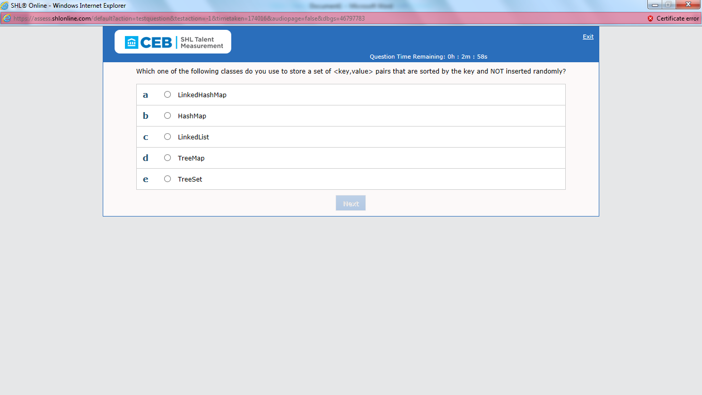

**Ans: d**

**32)Which one of the following is the reason the sample code above causes a compilation error?**

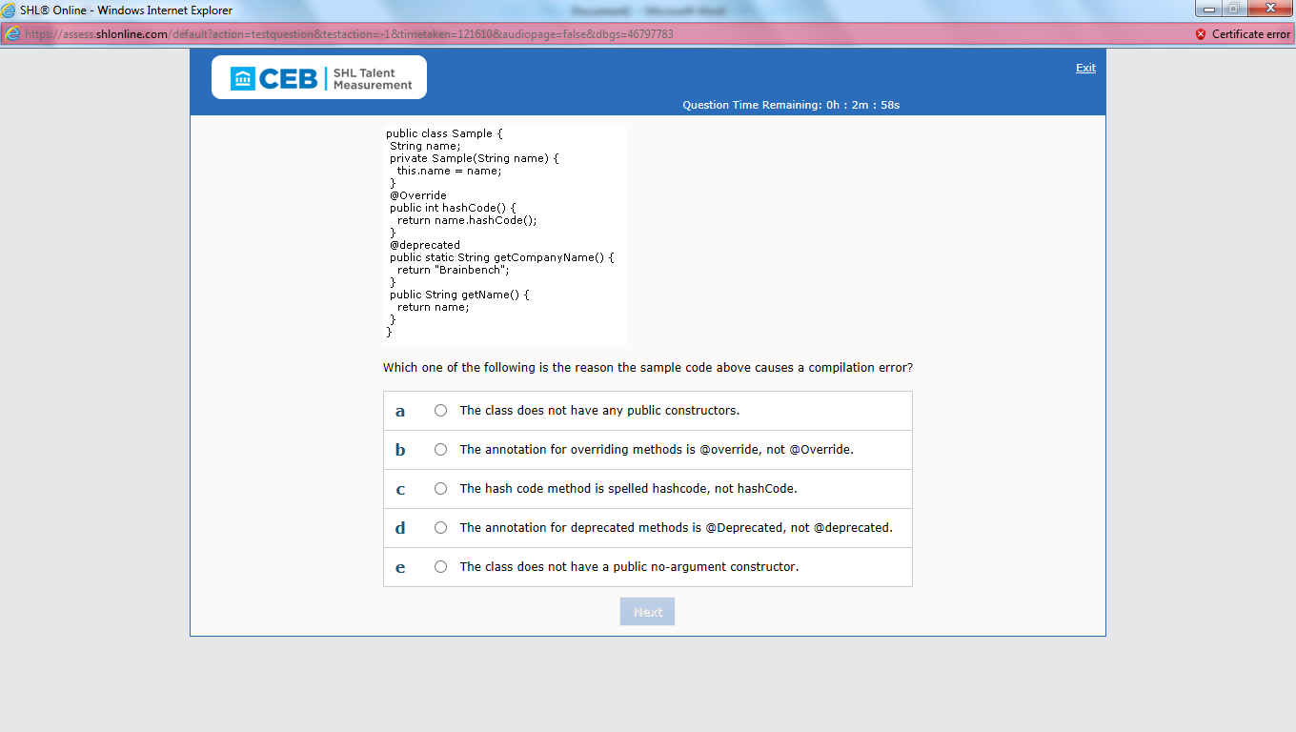

**Ans: d**

33) Which one of the following lines of code do you use to return the HTML text of the root Web page at www.brainbench.com?

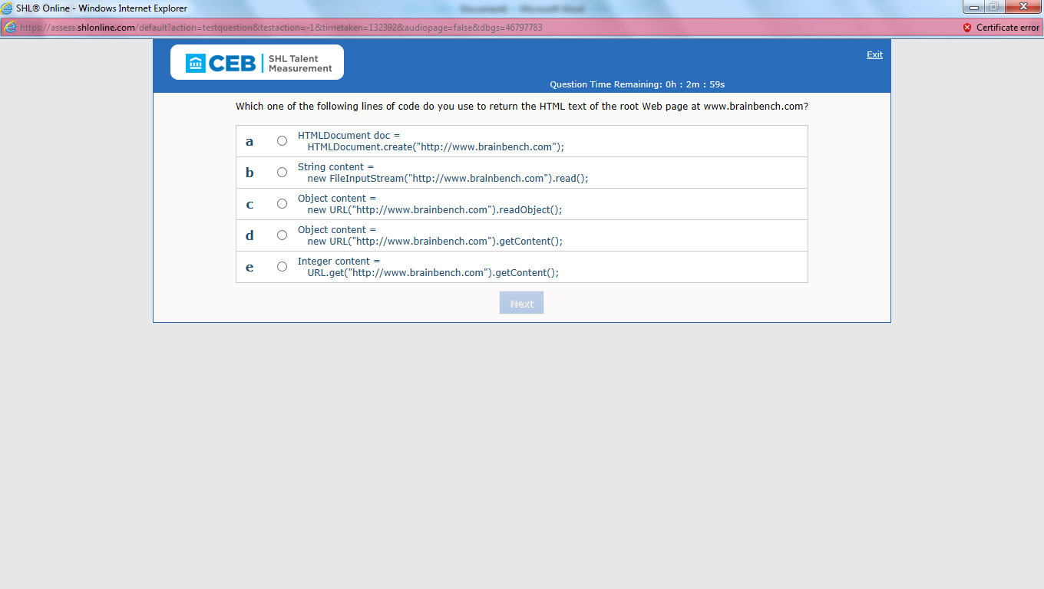

**Ans: d**

34)How do you count the number of lines in a text file?

**Ans: b**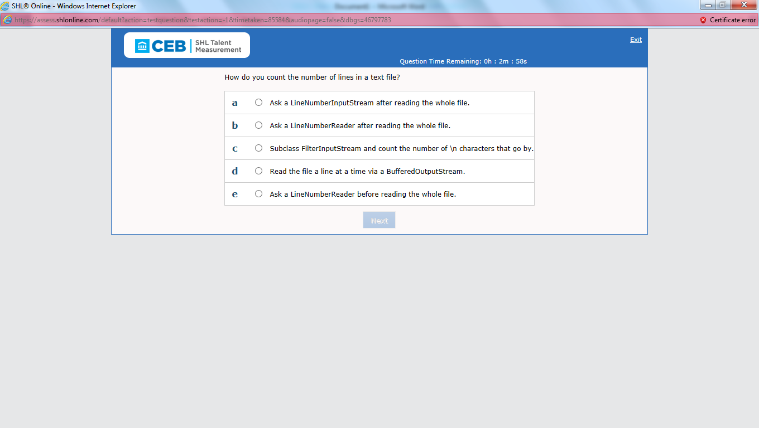

35)which one of the following mechanisms do you use to directly change an XML file from one DTD into another?

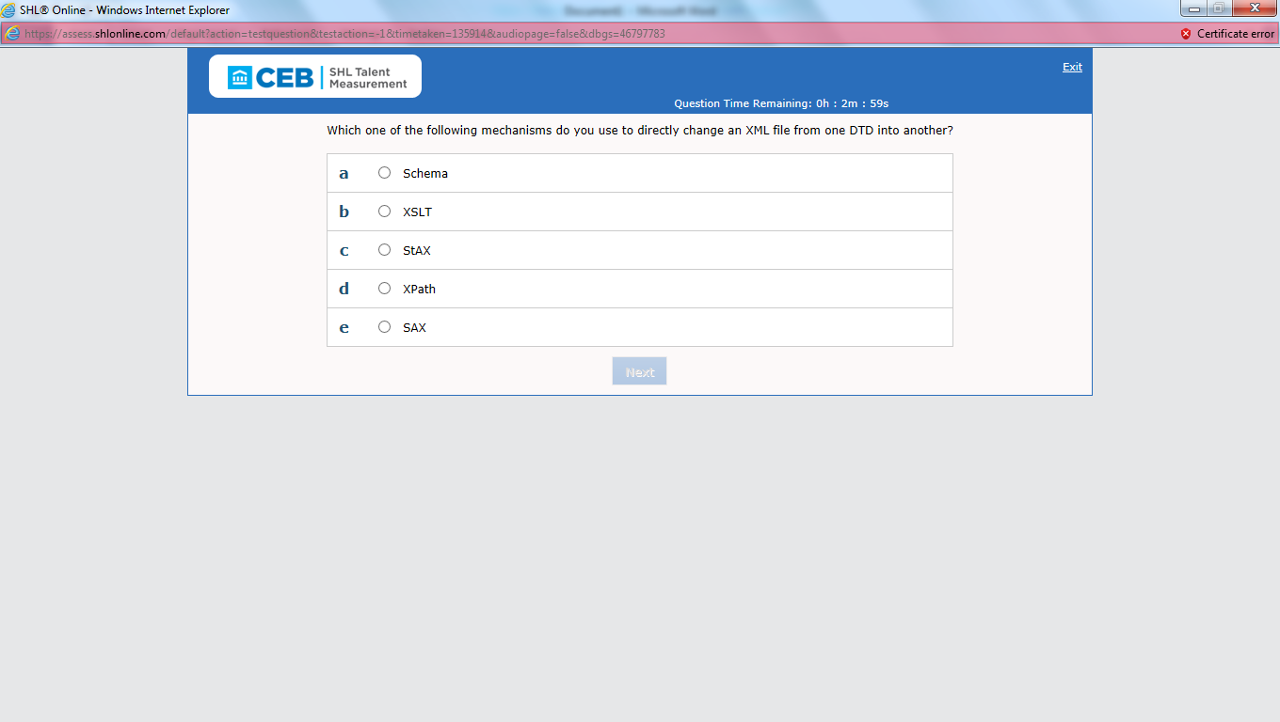

**Ans: b**

**36)which one of the following is the result when you run the above sample code?**

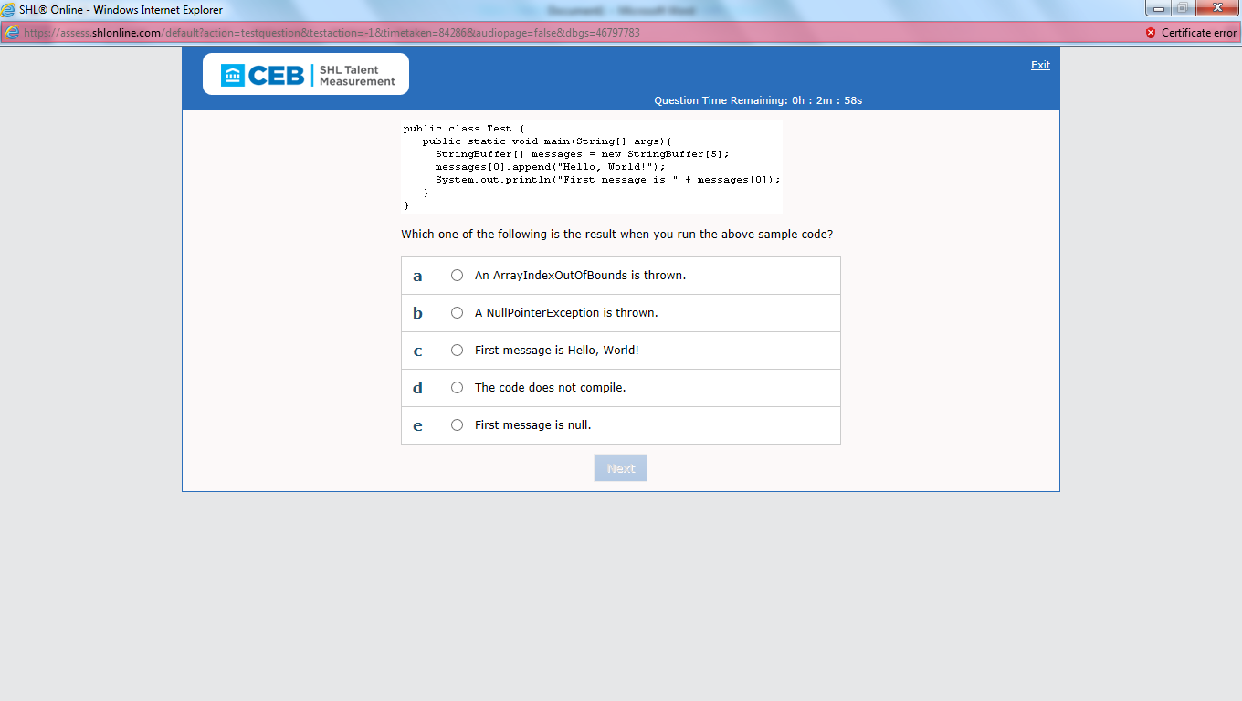

**Ans: b**

37)In the sample code above, after execution, what does the array named bArray contain?

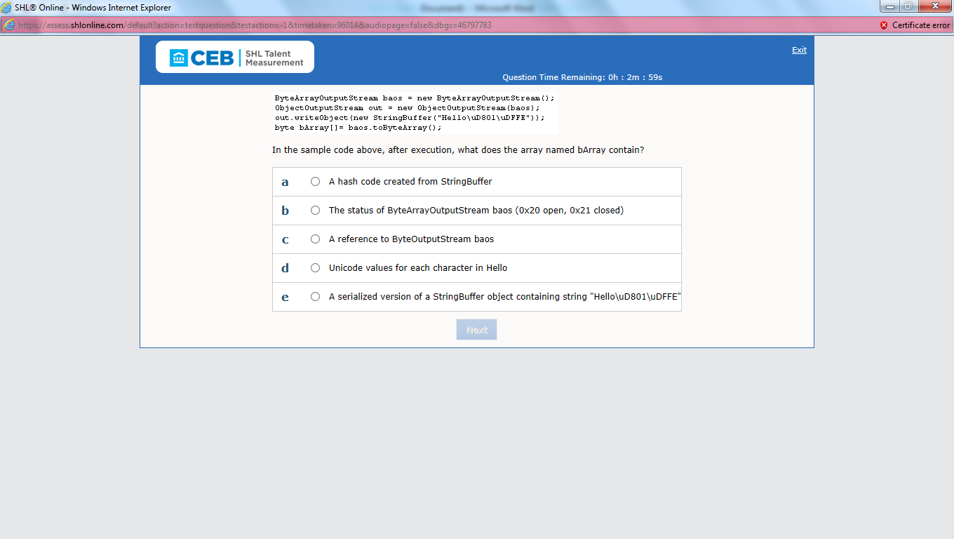

**Ans: e**

**38)which one of the following is NOT a valid refernce in an @see javadoc tag,when you want to refernce another field,,method,constr, or class?**

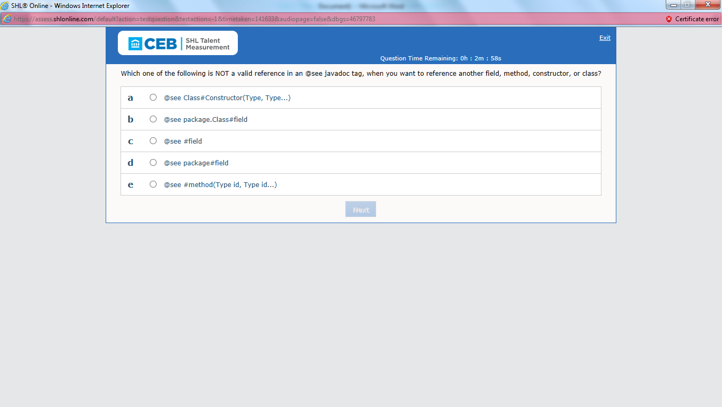

**Ans: d**

**39)which one of the following java APIs do you use to look up a Java Mbean?**

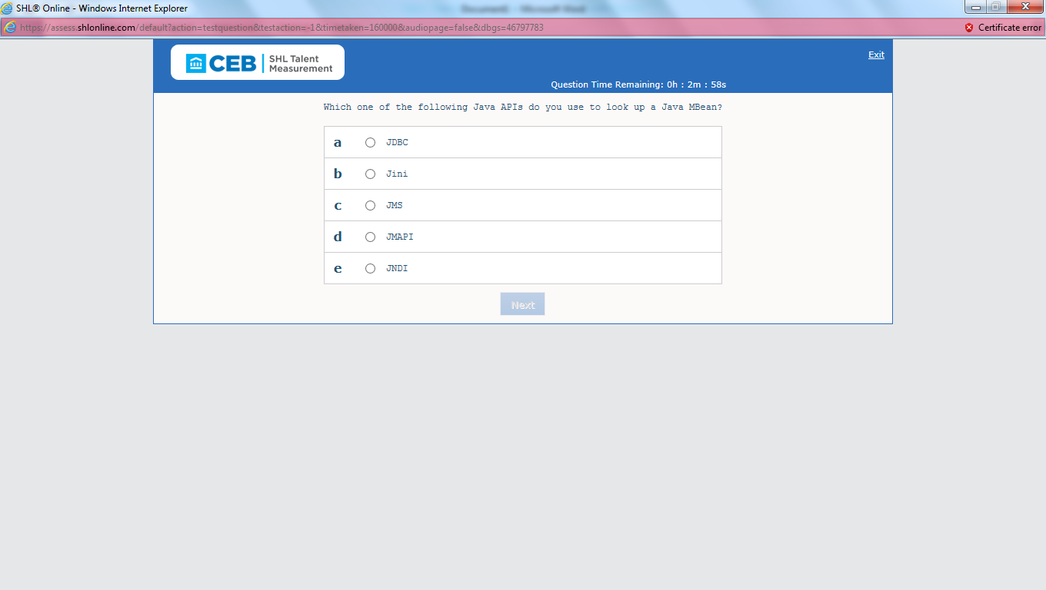

**Ans: b**

40)As defined in the sample code construct above, what interface must the Expression implement in order for you to use it … construct?

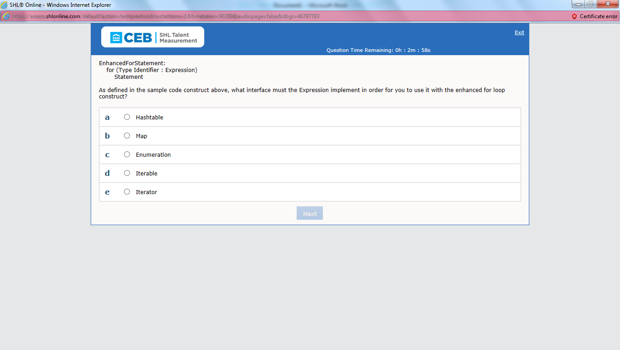

**Ans: d**

41) Assuming the correct import statements are present, how do you rewrite the sample code

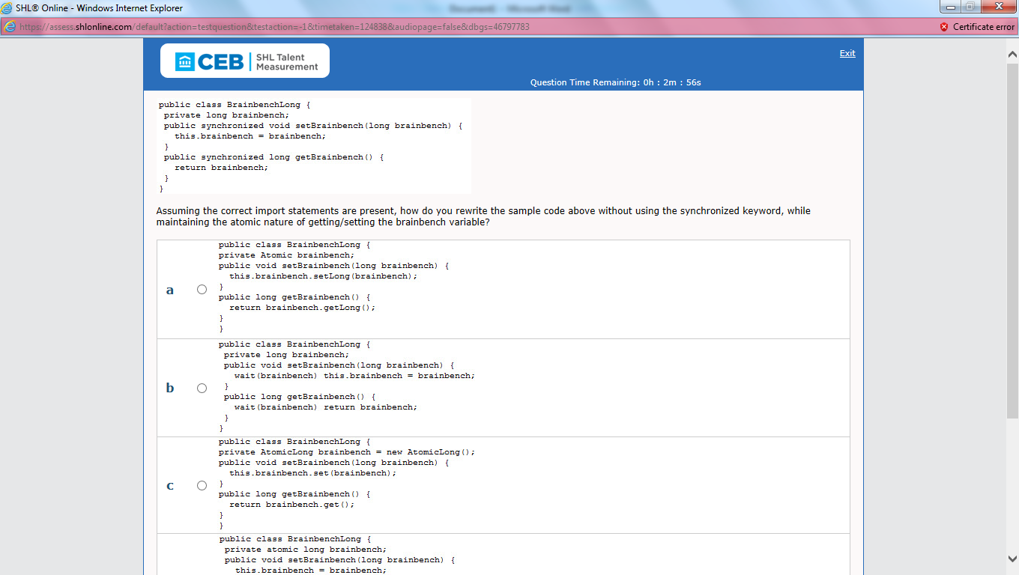

**Ans: c**

42)which class, found in the javax.script package, servers as the discovery mechanism for the installed set

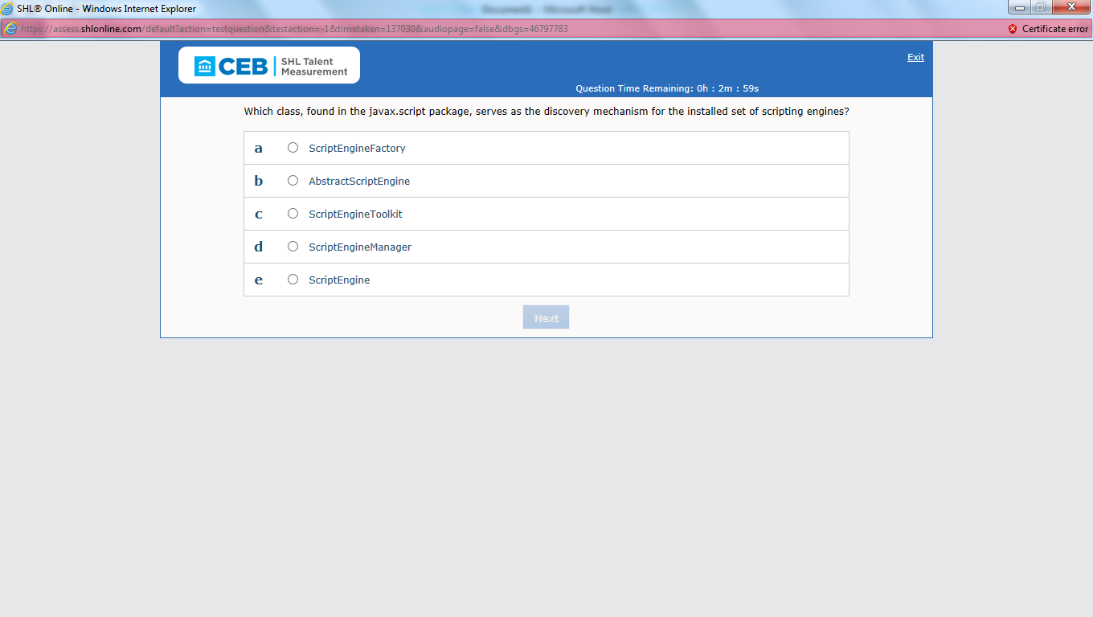

**Ans: a**

43)what is the output from running the command java TestSub after compilling the sample code above?

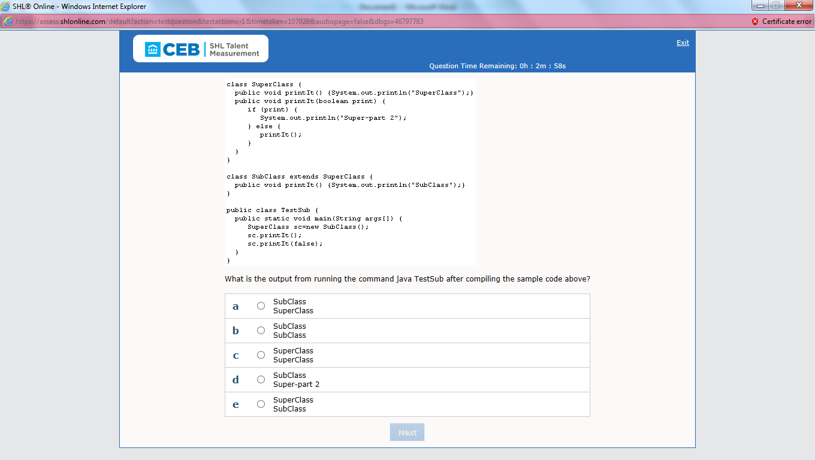

**Ans: b**

44)which one of the following is the output of the sample code above?

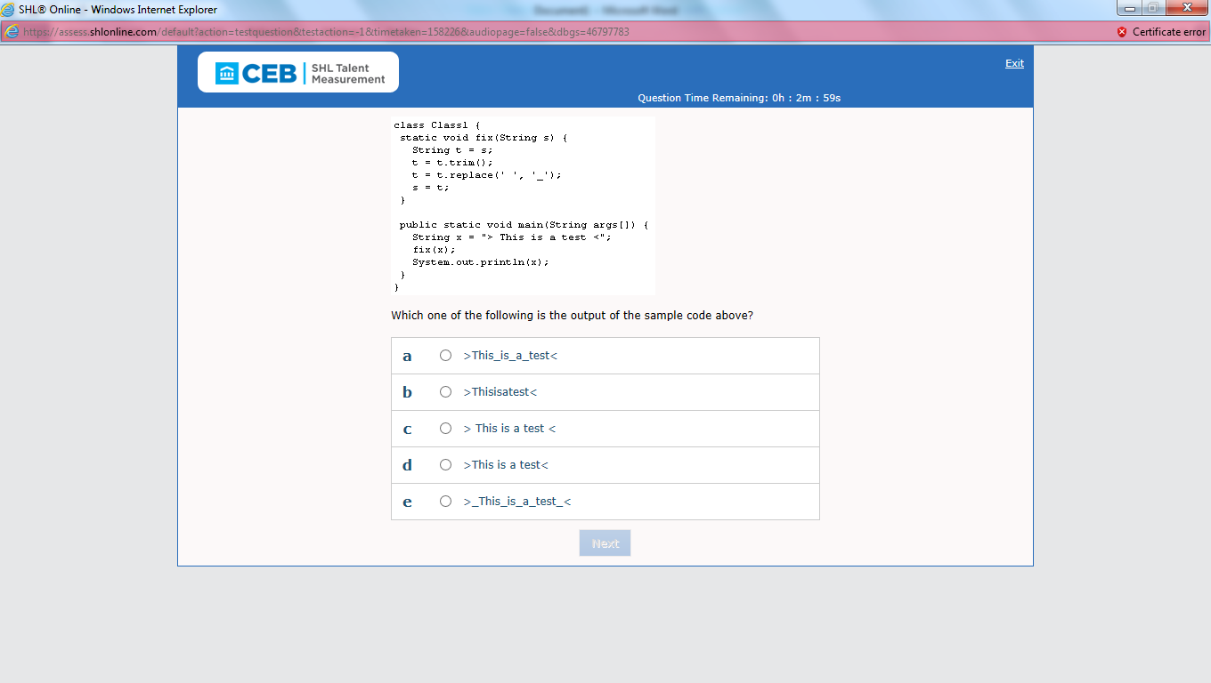

**Ans: c**

**45)In the scenario above, what happens when you add an item to the itemList from the adder thread?**

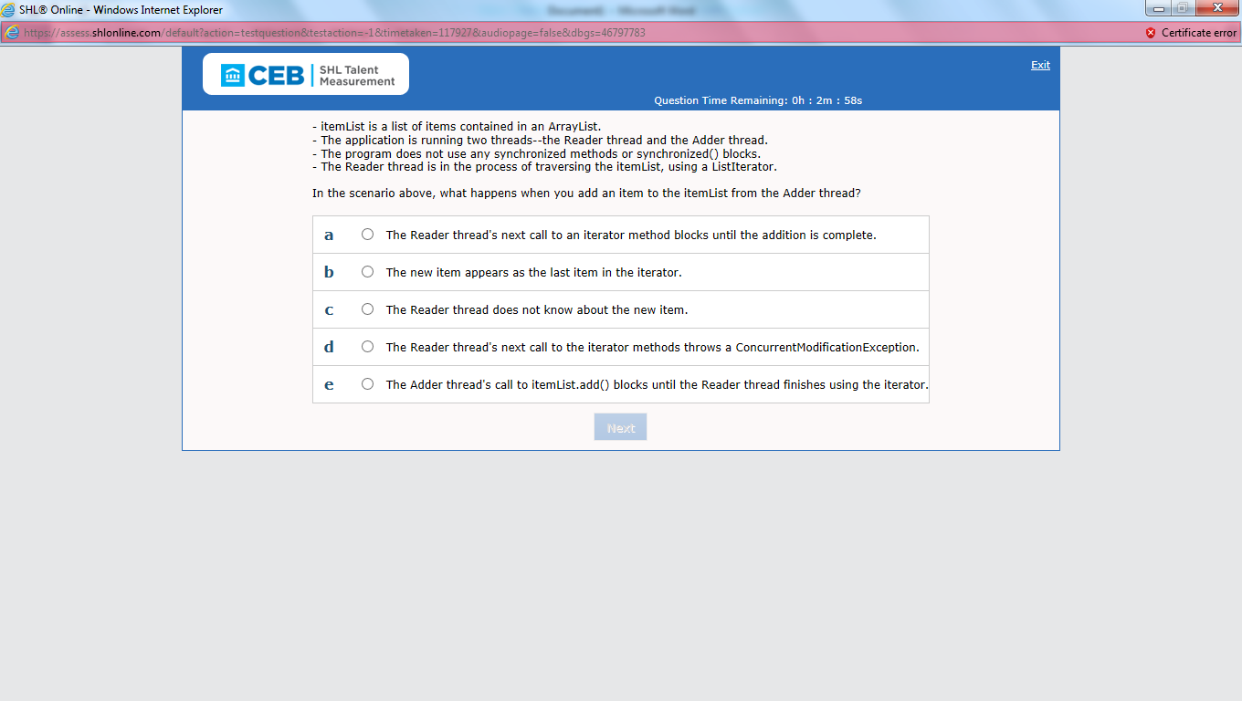

**Ans: b**

**46)what is the output of the sample code above?**

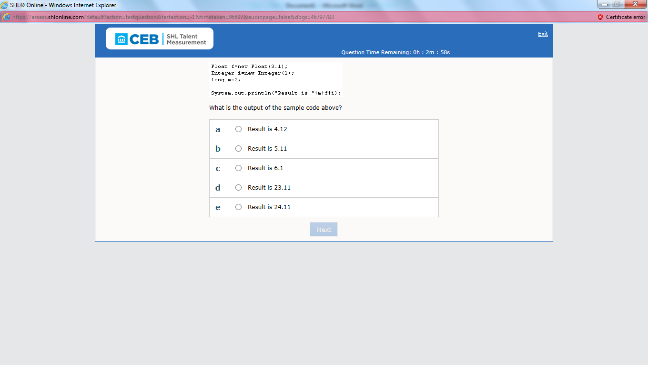

**Ans: d**

47)what is the error in the sample code above?

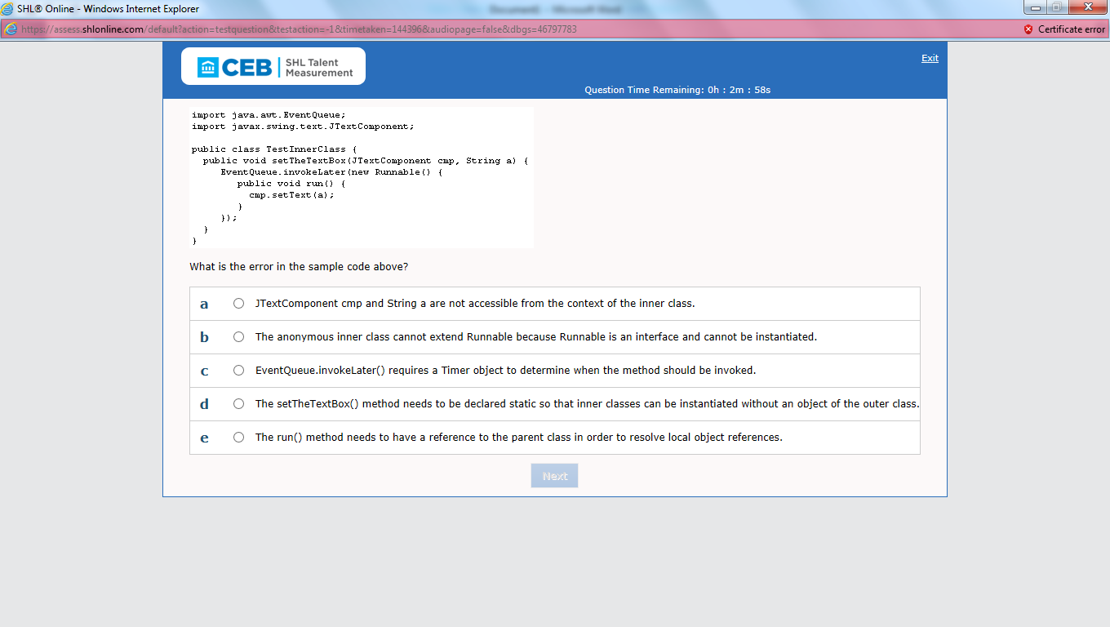

**Ans: a**

**48)which one of the following method declaration is valid?**

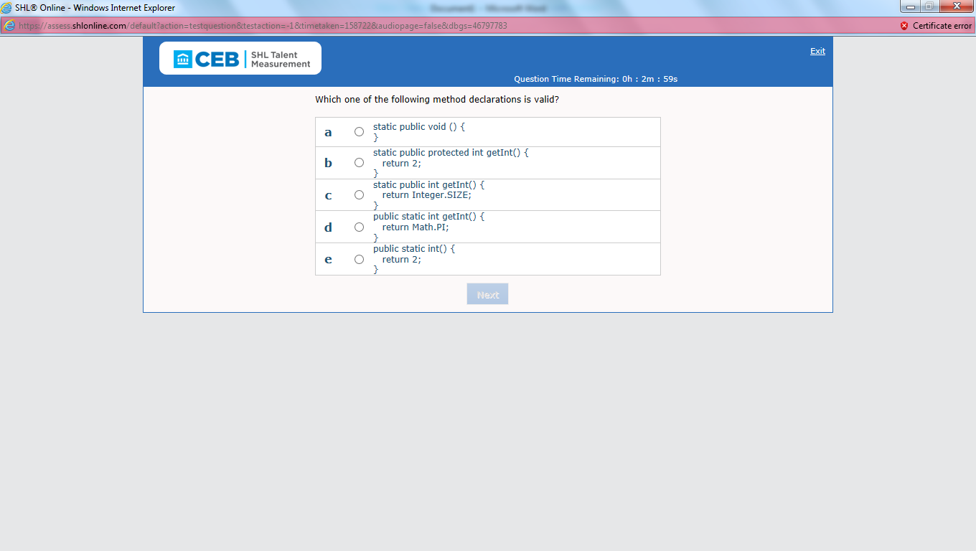

**Ans: c**

49)what is the value of d after the sample code above is executed?

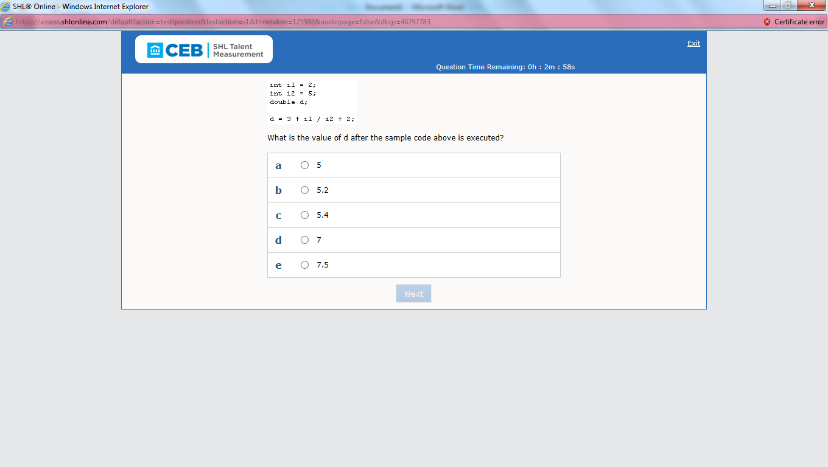

**Ans: a(needs to check in eclipse)**

**50)What is the purpose of the Facade structural pattern?**

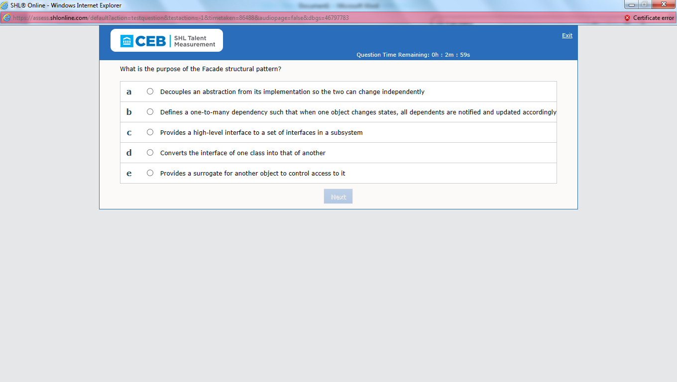

**Ans: c**

51)what must you add to the declaration of the parameter named brainbench in order for the sample code above to compile?

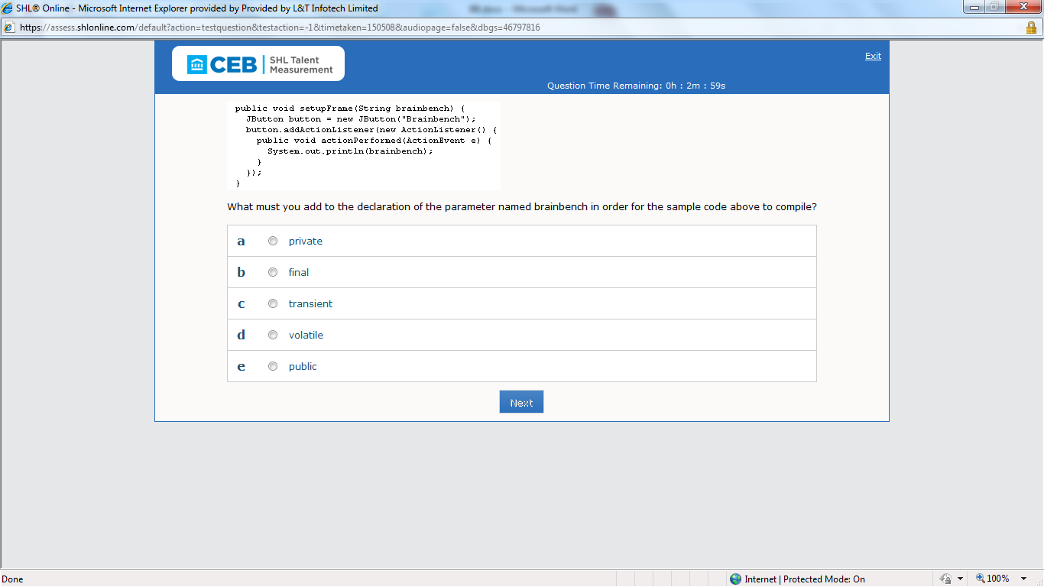

Ans: b

52)which one of the following items ranks the order of access modifiers from LEAST visbility to MOST?

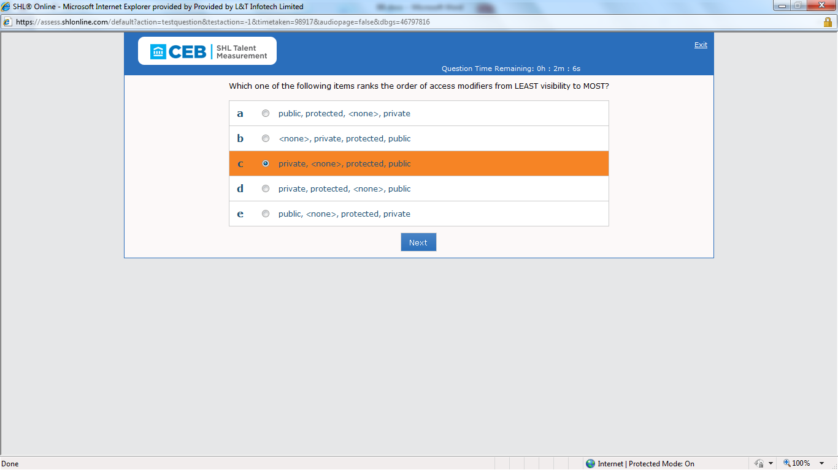

Ans: c

53)which one of the following statements returns the IP address of www.brainbench.com?

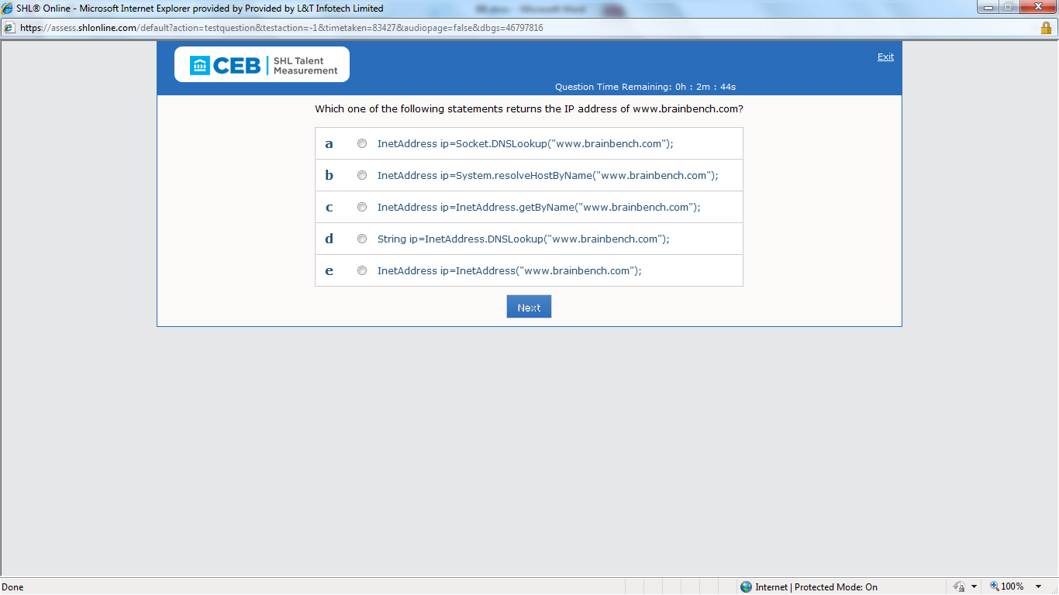

Ans: c

54)To what do you add data to a swing component, such as a Jtable, Jtree,or JList?

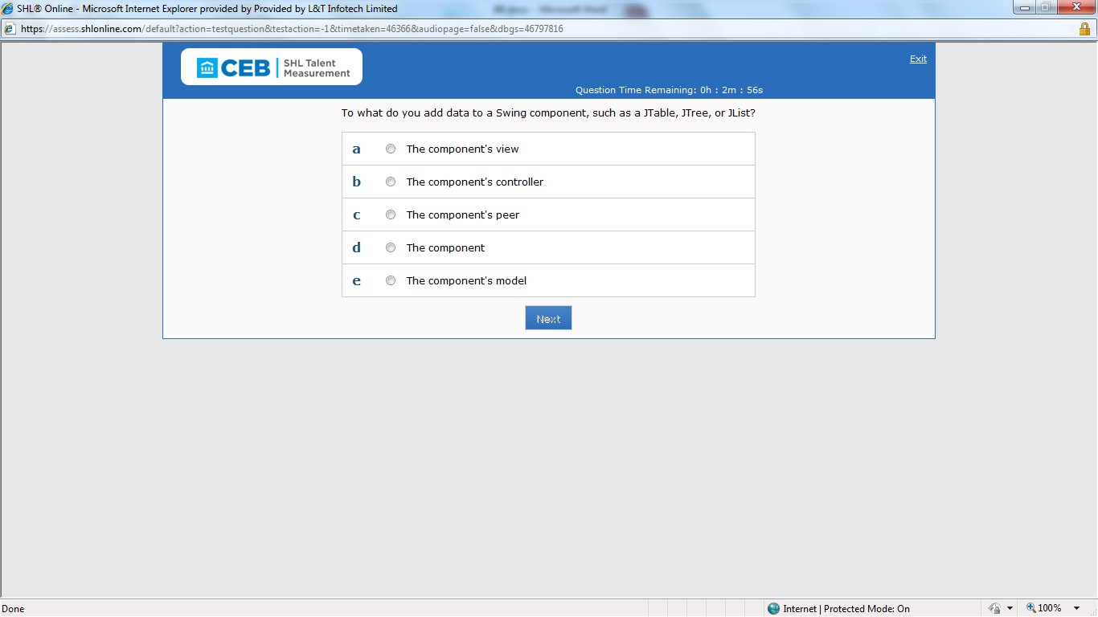

Ans: e

55)which collection below allows you to find it from growing beyond a certain size?

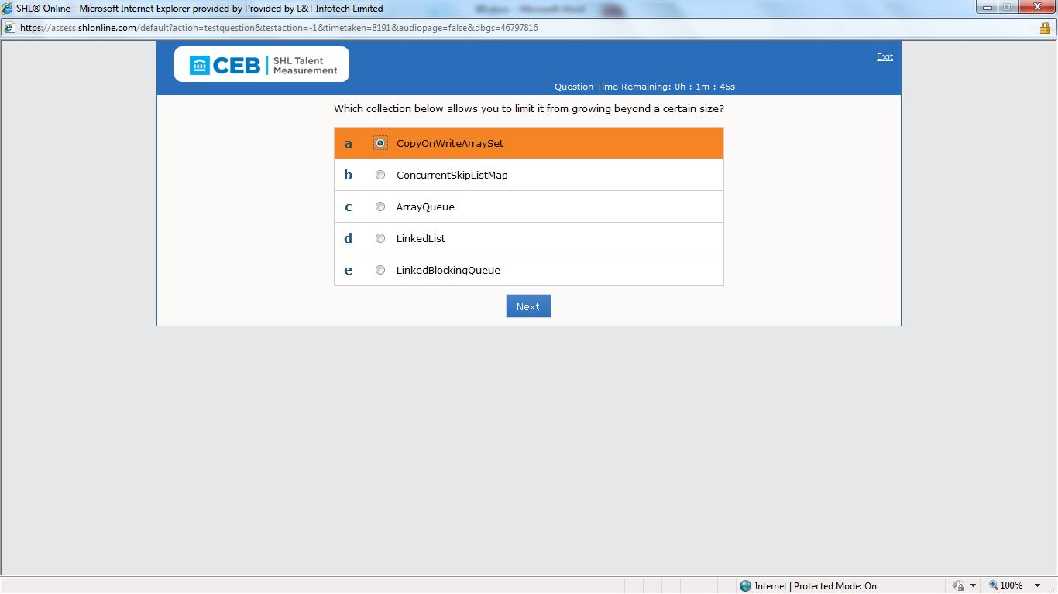

Ans: e

56)Referring to the sample code below, what is the result when invoking the following statement?

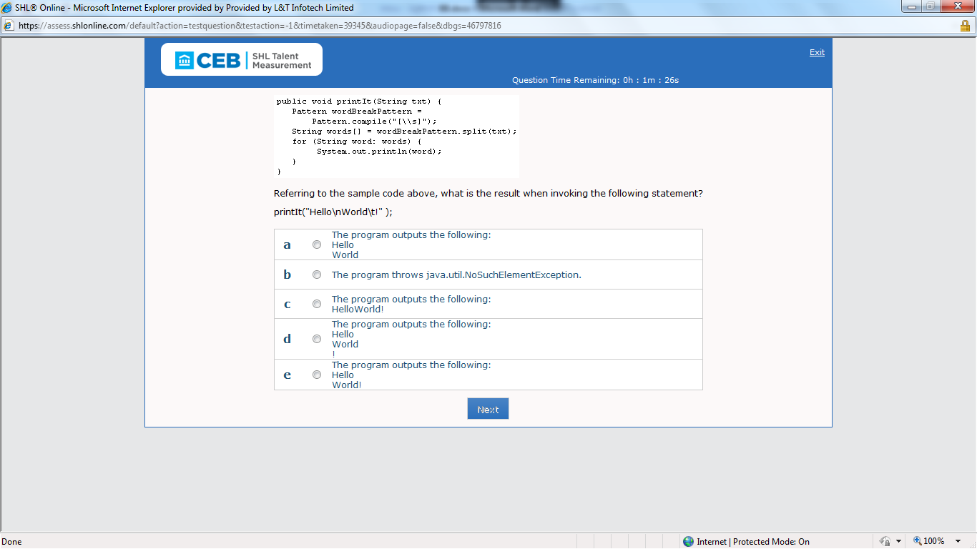

Ans: (d) Hello

World

!

57)what is the purpose of the Façade structural pattern?

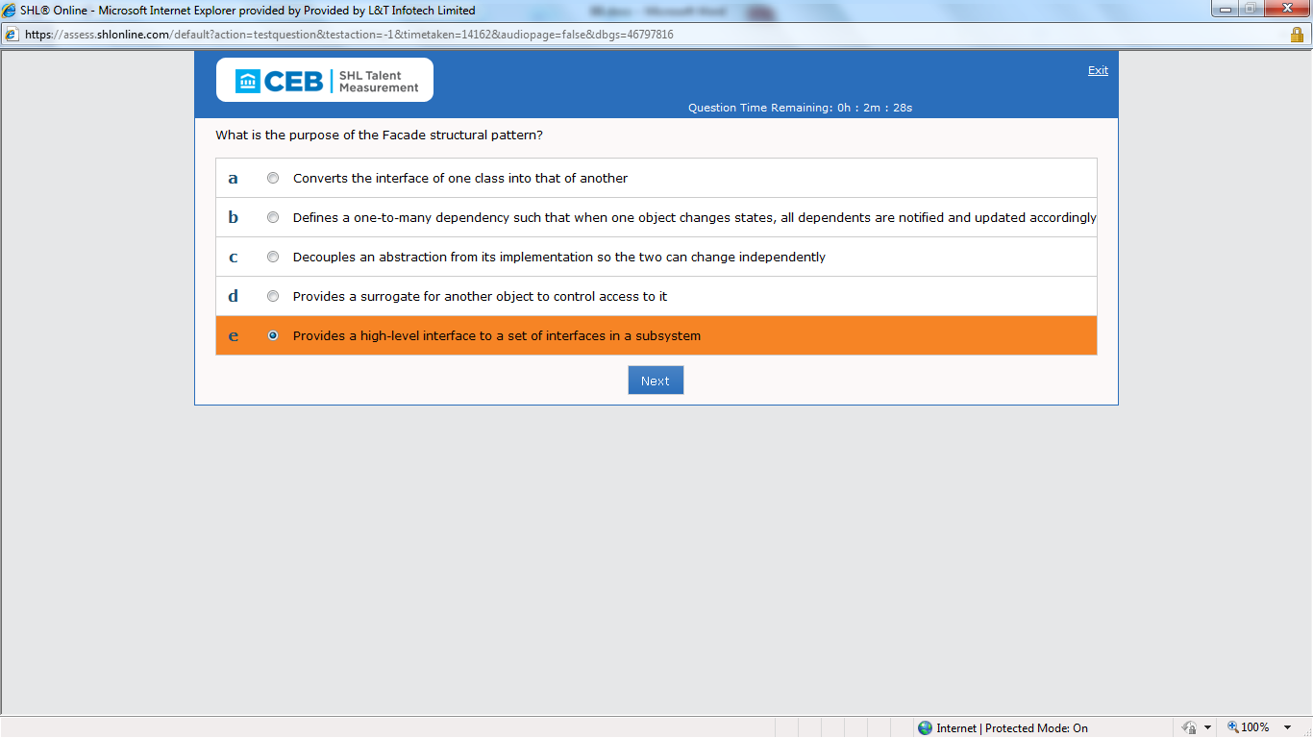

Ans: e

58)which one of the following code strings do you use to convert the for loop in the sample code above to a for each loop?

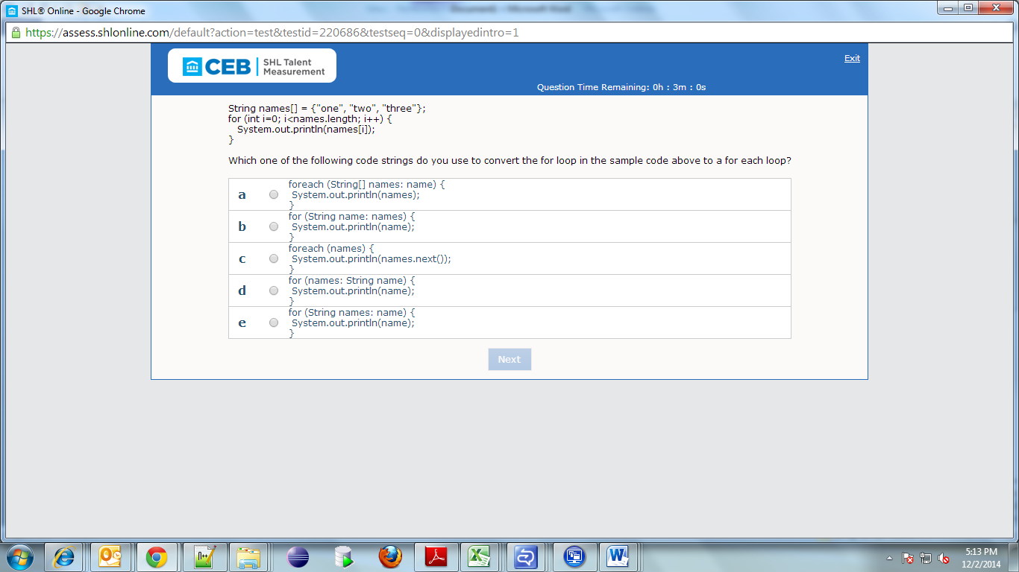

Ans: b

59)which one of the following lines do you use to place the applet defined in the sample code above within a web page?

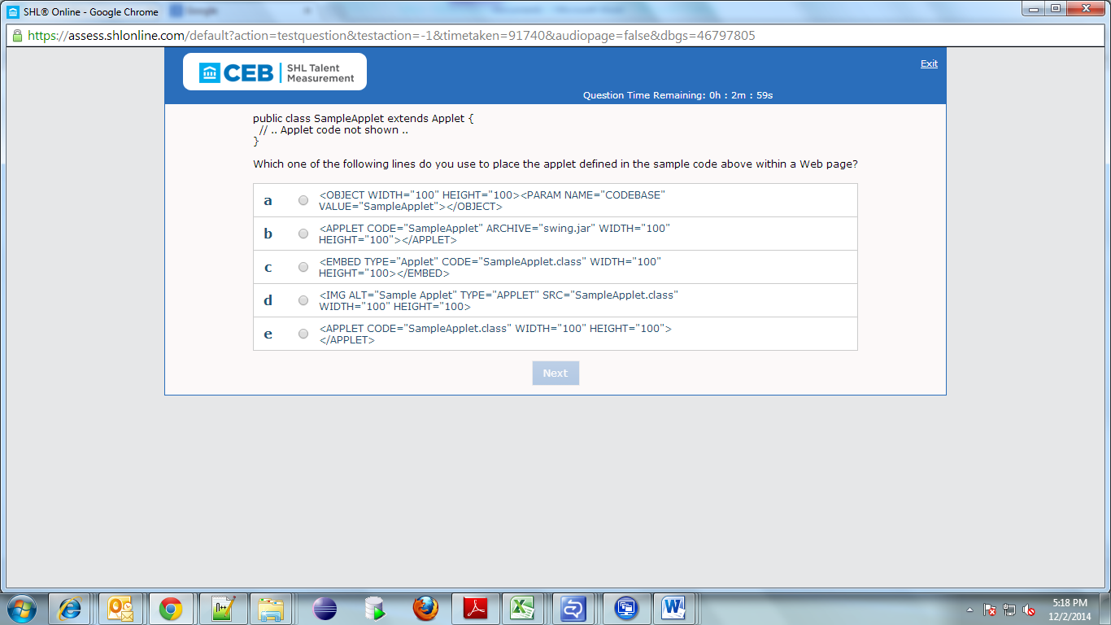

Ans: e

60)How do you change the sample code above so that a compressed version of myObject is saved?

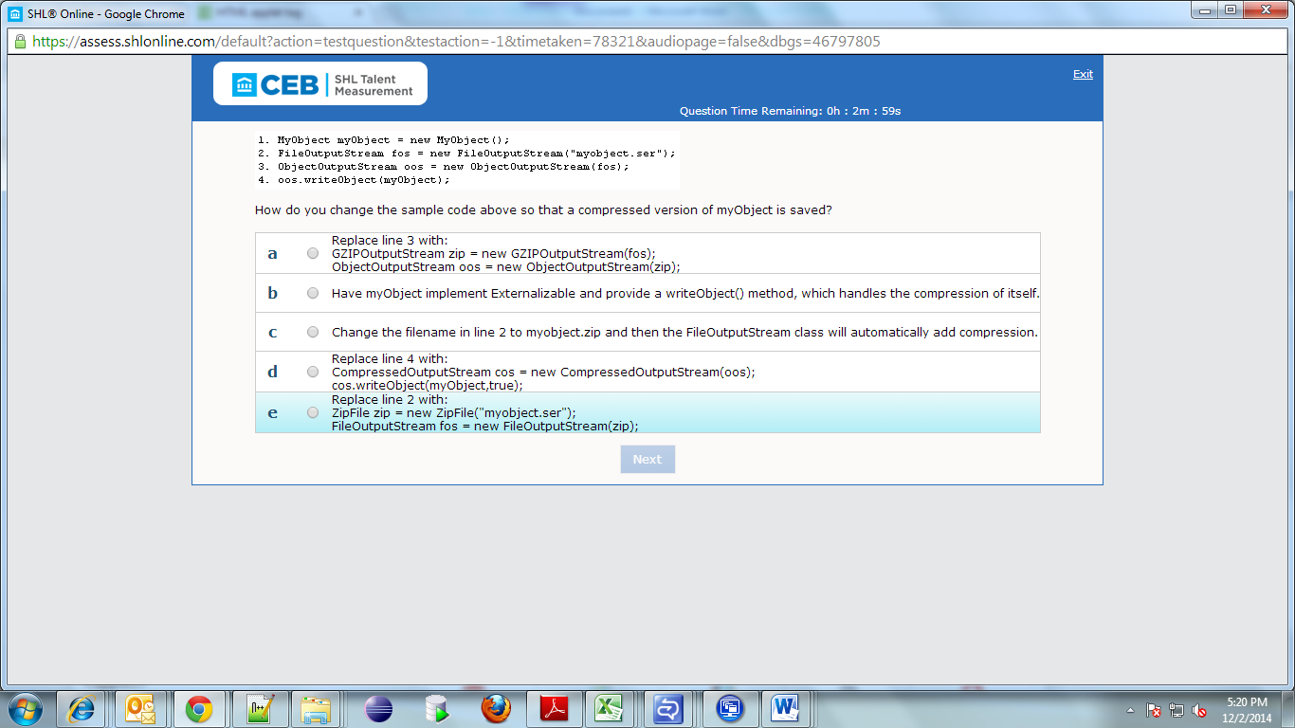

Ans: a